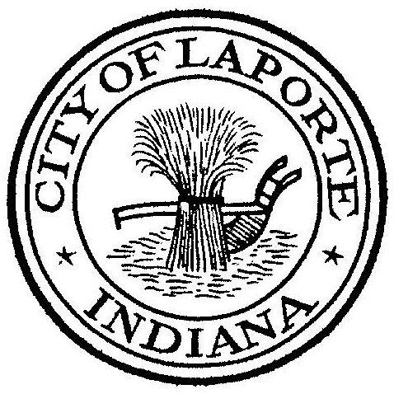
Board of Public Works and Safety
Jessica Romine, Member Tom Dermody, Mayor Mark Kosior, Member
City Hall 801 Michigan Ave., La Porte, IN 46350
Wednesday, January 3, 2024
9:00 AM
AGENDA
- Call To Order
- Pledge Of Allegiance
- Approval Of Minutes
- Public Comment: In Person and via Facebook Live
- Clerk-Treasurer: Claims Approval
Conflict of Interest Form(s)
Request Permission to issue checks to La Porte Invitational Vendors
- Department Head Reports
- New Business:
-Nick Otis: Fire CBA 2023
-Nick Minich: Request to Re-advertise and Bid: Stone Lake Trail Phase 2&3
Request to Advertise/Bid: Slicer Pathway
-Jerry Jackson: Pay Request #6 for Contract 2A Letters & Numbers
Phosphorus Paving Contract Pay Request #1
NIES General Service Agreement
-Paul Brettin: Request Permission to Sell K9Kennel for Dodge Durango
Contract for Legal Services: Merit Commission
- Unfinished Business:
-Tabled: Professional Service Agreement
- Other Business: Next regularly scheduled meeting: Wednesday, January 17, 2024 at 9a
10) Adjourn

